Curriculum vitae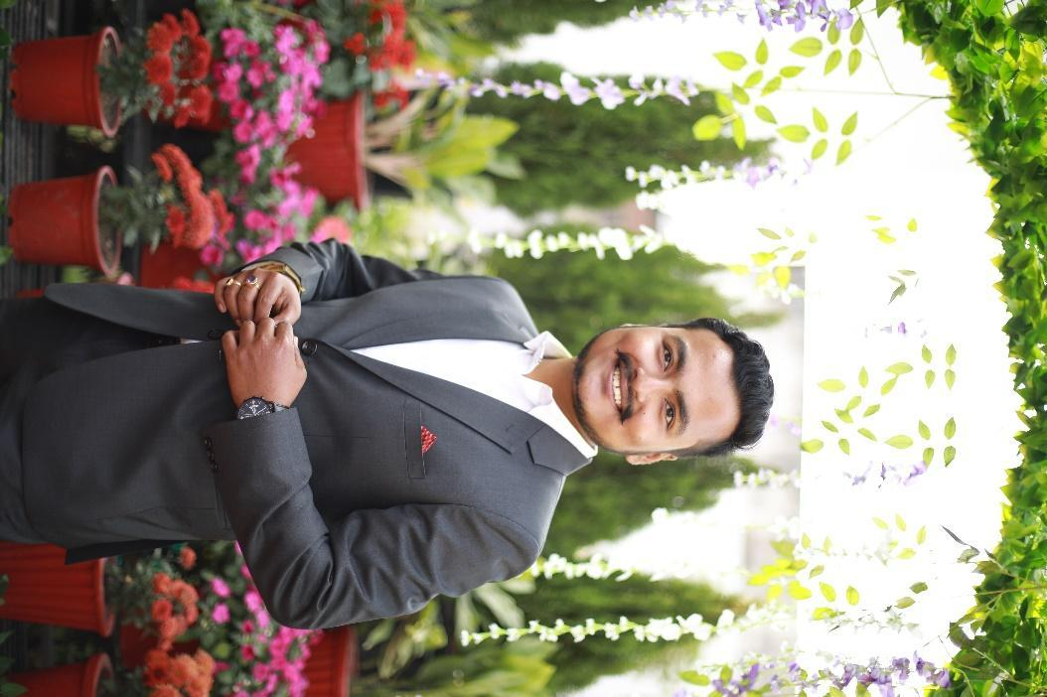

Tanmay Dasgupta

Assistant Professor

Department of Mining Engineering

BIT-SINDRI, DHANBAD

| Personal information | | | | | | | | | | |
| --- | --- | --- | --- | --- | --- | --- | --- | --- | --- | --- |
| Date of birth | | | 08-October-1992 | | | | | | | |
| Nationality | | | Indian | | | | | | | |
| Email | | | tanmaydas.min@bitsindri.ac.in,tdggec1992@gmail.com | | | | | | | |
| Contact no. | | | +91-8840144886,+91-9128985807 | | | | | | | |
| Office address | | | Department of Mining Engineering, BIT Sindri  Dhanbad-828123, Jharkhand, India | | | | | | | |
| Home address | | | A-3,B Block ,3rd Floor Maheshwar Dham Apartments, New Karmik Nagar, Loharkulli, Dhanbad ,Jharkhand 826001 | | | | | | | |
| Web page address | | | Home page address: <https://www.bitsindri.ac.in/faculty-profile/tanmay.html>  Researchgate profile:www.researchgate.net/profile/Tanmay-Das-Gupta | | | | | | | |
| Academic qualification | | | | | | | | | | |
| S/NO. | **DEGREE** | **YEAR** | | | | **UNIVERSITY /INSTITUTE** | | | | |
|  | B.E  Mining engineering | 2015 | | | | GOVERNMENT ENGINEERING COLLEGE-BILASPUR  CHHATTISGARH SWAMI VIVEKANAND TECHNICAL UNIVERSITY-BHILAI | | | | |
|  | M.Tech  Mine environment specialisation | 2017 | | | | INDIAN INSTITUTE OF TECHNOLOGY-BHU, VARANASI | | | | |
|  | PhD.  Mining engineering | Pursuing | | | | INDIAN INSTITUTE OF TECHNOLOGY-ISM, DHANBAD | | | | |
| Field of interest | | | Mine Ventilation, Mine Fire, Mine Environment, Mine Planning, Computational Fluid Dynamics, Environmental Impact Assessment,Mine Legislation | | | | | | | |
| Professional experience including internships | | | | | | | | | | |
| Coal India limited | | | June 2013 to July 2013 | | | | Haldibadi Underground Coal Mine, West Jhagrakhand, Koria, Chattisgarh, South Eastern Central Coalfields. | | | |
| Coal India limited  . | | | July 2014 to August 2014. | | | | Mahan -1 Open Cast Mine, Bhattgaon, Surajpur, Chhattisgarh, South Eastern Central Coalfields | | | |
| Career point education Pvt limited | | | October 2012-august 2015 | | | | Physics Faculty (Part -Time) ,Career Point Pvt.Limited ,Bilaspur Franchise ,Chhattisgarh | | | |
| National Project Implementation Unit NPIU, MHRD, Government Of India. | | | January 2018-September 2021 | | | | World Bank assisted project, deputation in Jharkhand @ BIT-Sindri. | | | |
| Department Of Higher Technical Education And Skill Development ,Government Of Jharkhand | | | October 2021-Till Present | | | | BIT-Sindri, Dhanbad | | | |
| Research Experience | | | | | | | | | | |
|  | Doctoral Research scholar (PT), IIT-ISM, Dhanbad (2019 to present)  Thesis title :**Experimental and Numerical Investigations of Coal Spontaneous Combustion Kinetics and Mine Fire.**  To develop and standardize a method to generate combustion kinetics data of different coal and categorizing their self heating propensity.  To carry out CFD modeling for studying the role of temperature, moisture, oxygen concentration and airflow rate on the coal spontaneous combustion phenomenon and mine fire.  Supervisor: Dr D.P Mishra | | | | | | | | | |
|  | Postgraduate scholar, IIT- BHU, Varanasi (2017).  Thesis title: **Degree of investigation for gassiness of underground coal mines of India with particular reference to methane utilisation.**  Supervisor: Prof. Aarif Jamal  Estimating the methane gas content of coal samples collected from the deepest coal mines of India. Determining the grade of coal and its gross calorific value using proximate analysis by I.S. specifications. | | | | | | | | | |
| Academic Institute Credentials | | | | | | | | | | |
|  | Courses taught | | | Undergraduate level  Theory: 06  Practicals:02 | | | | | | |
|  | GATE | | | Undertaking two courses with a maximum level of exposure through classroom mode, MOOCs, NPTEL, google classroom, evaluation and feedback | | | | | | |
|  | Accreditation status | | | Achieved NBA accreditation in 2019 for Undergraduate B.Tech program of the mining engineering department BIT, Sindri  Member of the core departmental NBA committee | | | | | | |
|  | Examination | | | Question Paper Setting, Departmental university examination Evaluation Committee Member For Both Vinoba Bhave University, Jharkhand University Of Technology,  Aditya Institute Of Technology And Management, Tekkali  The Institution Of Engineers(I.E.) Examination Forum, Bikaner technical university,Rajasthan | | | | | | |
| Administrative experience | | | | | | | | | | |
| AT INSTITUTE LEVEL | | | | | | | | | | |
|  | R&D relation coordinator (M.N. dept. representative) with CIMFR, Dhanbad under the memorandum of understanding of BIT, Sindri and CSIR-CIMFR | | | | | | | | | |
|  | Planning committee member for ***CENTRAL RESEARCH FACILITY BUILDING* (CRF)** , BIT SINDRI | | | | | | | | | |
|  | ***Coal characterisation Laboratory*** & MINING Analytical research center at the department of mining engineering, BIT Sindri, proposal submitted and approved by DST, Government of Jharkhand **(Budget-1.2 cr)**  Status: Established | | | | | | | | | |
| AT DEPARTMENTAL LEVEL | | | | | | | | | | |
|  | R&D Co-Ordinator For The Mining Engineering Department. | | | | | | | | | |
|  | Set-Up And Inception Of Mine Environmental Engineering Laboratory in The Department Of Mining Engineering, BIT SINDRI | | | | | | | | | |
|  | Professor Incharge For Mine Environmental Engineering Laboratory, Mine Ventilation Laboratory And Coal Quality Assessment Laboratory | | | | | | | | | |
|  | Member Of Departmental Academic Council, BIT SINDRI. | | | | | | | | | |
|  | Purchase Committee Indenting Officer | | | | | | | | | |
|  | Seminar/Workshop Coordinator | | | | | | | | | |
|  | B.Tech. Project Coordinator | | | | | | | | | |
|  | Supervised B.Tech Projects:28 | | | | | | | | | |
| Conference/ Workshop/Seminar/ organised | | | | | | | | | | |
| Name of The Conference: Recent Advances in Mining Technology (RAMT)  December 2018  Role /Responsibility: Organising Secretary  Sponsoring agency: TEQIP III  Participants:150 | | | | | | | | | | |
| Conference/ Workshop/Seminar/ attended | | | | | | | | | | |
| SL/NO. | **TITLE OF SYMPOSIUM/ WORKSHOP/SEMINAR/FDP/ SHORT – TERM COURSES** | | | | **DATE** | | | | **ORGANISING INSTITUTE** | |
|  | Faculty Development Programme  Under TEQIP-III | | | | January/February 2018 | | | | IIT-Madras | |
|  | Outcome-based education and accreditation | | | | April 2018 | | | | BIT-Sindri | |
|  | Flow and process simulation in process industries FASIPI | | | | October/November 2018 | | | | Chemical engineering department BIT-SINDRI | |
|  | Recent advances in mining technology  RAMT | | | | December 2018 | | | | The mining engineering department, BIT-Sindri | |
|  | Digital pedagogy and learning outcomes | | | | April 2019 | | | | IIT-Kharagpur | |
|  | Water scenario of Dhanbad district: emerging challenges | | | | July 2019 | | | | Department of geology, BIT-Sindri | |
|  | Artificial intelligence and machine learning using python | | | | April 2020 | | | | Finland labs Pvt limited | |
|  | Digital transformation in teaching-learning process SWAYAM course | | | | April 2020 | | | | IIT-Bombay | |
|  | Coursera online course on Autodesk -fusion 360 | | | | June 2020-September 2020 | | | | IIT-(ISM)-Dhanbad | |
|  | Udemy course on SOLIDWORKS CAD | | | | June 2021-august 2021 | | | | Udemy inc. san francisco california, USA | |
|  | Skill-lync GUI based ANSYS CFD  FLUENT course | | | | october 2021–january 2022 | | | | skill-lync ,EpowerX Learning Technologies Pvt Ltd ,chennai. | |
| Membership of the professional body | | | | | | | | | | |
| Mining engineering society, IIT-BHU, Varanasi lifetime membership. | | | | | | | | | | |
| Executive member BHU Alumni Association, Dhanbad Asansol chapter | | | | | | | | | | |
| R&D and Consultancy project | | | | | | | | | | |
| Sl/No. | **Project Title** | **Sponsoring Agency** | | | **Role** | | | **Durations** | **Project Budget** | |
| 1. | Environmental monitoring and occupational hazard survey of underground coal mines at Jitpur collieries, SAIL | **SAIL colliery division** | | | Project Investigator | | | 24 months (2022) | 13.6 lakhs | |
| 2. | Ambient air analysis and water quality determination at different locations of jitpur mines | **SAIL COLLIERY DIVISION** | | | project investigator | | | 24 months  (2023) | 7 lakhs | |
| 3. | investigation of spontaneous combustion kinetics of Indian coal. | **TeXMin Foundation IIT ISM DHANBAD & DST, Govt of India.** | | | Project investigator | | | 24 months  2023 | 15 lakhs | |
| Scholastic achievements | | | | | | | | | | |
| * Secured rank 1127 in the Chhattisgarh pre-engineering entrance test, received Chhattisgarh state scholarship for CGPET rank holder in mining batch of 2011 in GEC, Bilaspur. * All India rank of 427 in GATE 2015 and 273 in GATE 2017. * Acquired Mine’s Gas Testing Certification from Directorate General of Mine Safety – Ministry Of Labour And Employment, Government of India. | | | | | | | | | | |
| Publications | | | | | | | | | | |
| National Conference | | | | | | | | | | |
| Sl/no | **Title of the paper** | **Name of the Conference in which publication has been made** | | | | | | **Vol/No.** | **Publication Year** | Pages |
|  | Coal Bed Methane: A Critical Approach in Indian Context | National Conference on Recent Challenges in Mining Industries -RCMI, CIMFR-DHANBAD | | | | | | RCMI proceedings | 2018 | 245-258 |
|  | An Efficient Electrical Power Supply System For Mines. | National Conference on Control and Automation in Electrical Engineering  AITM, HYDERABAD | | | | | |  | 2018 |  |
|  | Environmental Aftermath In Dhanbad District: A Review | Technological advancement and emerging mining method, TAEMM-2018  CSIR-CIMFR-DHANBAD | | | | | | TAEMM proceedings | 2019 | 372-382 |
|  | Optimisation of coal recovery using a different cutting pattern of the pillar in continuous miner panel by numerical simulation methods | National conference on “Advances in Mining (AIM-2020)  CSIR-CIMFR-Dhanbad | | | | | | AIM proceedings | 2020 | 229-241 |

